Lab 5

# Exercise One

# Make command output for a successful compile



# Exercise Two

# stringTest1.c

# The output from running the Makefile

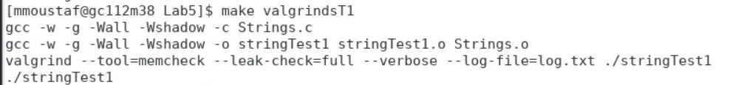

# Log.txt before free

# Logf.txt (After free)

# stringTest1.c

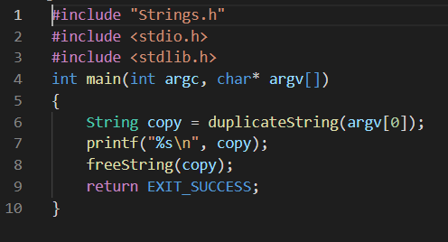

# A screen-shot of the program running (with freeString() ) and its output



# A screen-shot of the program running (without freeString() ) and its output



# Exercise 3

# the output from running your Makefile

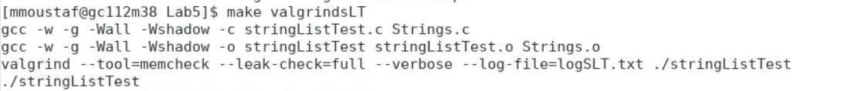

# the log-file outputs from the final run of valgrind

# stringListTest.c

# A screenshot of the program running and its output

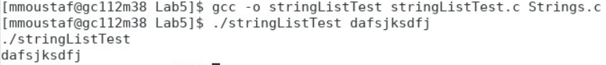

# Exercise 4

# the output from running your Makefile

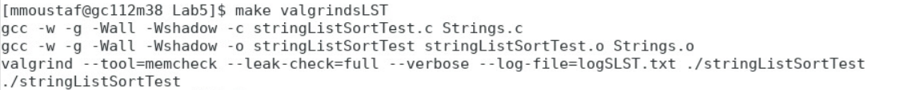

# the log-file outputs from the final run of valgrind

# stringListSortTest.c

# A screen shot of the program running and its output

# Exercise 5

# the screenshot of you pushing the program source to the FCS git

# the modified source code for the Strings module, including the Makefile

# Strings.h

# Strings.c

# Makefile

